Census 2020

Be Counted and Avoid Scammers!

Avoiding Scams Online
Phishing is a criminal act in which someone tries to get your information by pretending to be an entity that you trust. Phishing emails often direct you to a website that looks real but is fake—and may be infected with malware.

It is important to know that the Census Bureau will not send unsolicited emails to request your participation in the 2020 Census.
Further, during the 2020 Census, the Census Bureau will never ask for:
- Your Social Security number or Individual Taxpayer Identification Number.
- Your bank account or credit card numbers.
- Money or donations.
- The Census Bureau will not contact you on behalf of a political party.

95% of households will receive your census invitation by postal mail.

Invitations will start arriving around March 12, 2020. Mailings will be staggered. You can respond to the census on line, by email, or mail in a paper form. If you do not respond, there will be up to four reminders by mail, then an in person follow up in late April. Almost 5% of households will have the invitation dropped off at their home because they use PO boxes or are impacted by natural disasters. About 1% of households will be counted in person because they are very remote, and in select American Indian areas that have asked to be counted in person.
Remember: Everyone is counted, every response is confidential.

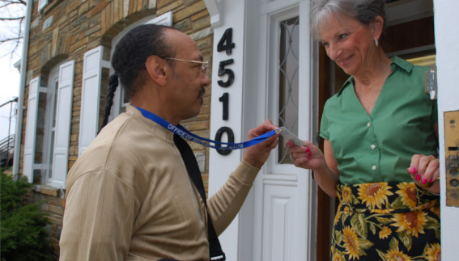
Staying Safe at Home

If someone visits your home to collect a response for the 2020 Census, you can do the following to verify their identity:
- First, check to make sure that they have a valid ID badge, with their photograph, a U.S. Department of Commerce watermark, and an expiration date.
- If you still have questions about their identity, you can call 800-923-8282 to speak with a local Census Bureau representative.
Field representatives
Field representatives who primarily do in-person interviews may call or come to your home. To verify that a person is a Census Bureau field representative, you can enter their name in the Census Bureau Staff Search, a database that lists name and contact information for all Census Bureau employees. https://www.census.gov/cgi-bin/main/email.cgi

You can also call the Census Bureau Regional Office to verify that the individual is a Census Bureau employee or to speak with their supervisor. Oregon’s regional office is in Los Angeles.
Los Angeles 1-800-992-3530 or (818) 267-1700
FAX: (818) 267-1714 TDD: (818) 904-6249
E-mail: Los.Angeles.Regional.Office@census.gov

How to identify a phone call from the Census Bureau
If your address was selected to be in a survey, The US Census may call you to participate. Some surveys are done exclusively by phone. They might also call you if they do not find you at home or when a personal visit is not convenient.
You may receive a call from one of the contact centers or from a field representative.

Contact centers
The Census Bureau uses two contact centers, one in Jeffersonville, Indiana, and the other in Tucson, Arizona. The caller will identify themselves and the name of the survey. If they are unable to reach you, they will leave a message with a case ID associated with your survey.
(812) 218-3144
(520) 798-4152
Most Census Bureau calls asking you to participate in a survey originate from one of the following numbers:
- (812) 218-3144, Jeffersonville Contact Center
- (520) 798-4152, Tucson Contact Center
If you receive a call and wish to independently verify that a number is from the Census Bureau, you can call one of the following numbers:
- 1-800-523-3205 Jeffersonville, IN
- 1-800-642-0469 Tucson, AZ
- 1-800-923-8282 Customer Service Center

Reporting Suspected Fraud
If you suspect fraud, call 800-923-8282 to speak with a local Census Bureau representative. If it is determined that the visitor who came to your door does not work for the Census Bureau, contact your local police department.

Fighting 2020 Census Rumors
If you see or hear false information about the 2020 Census or the U.S. Census Bureau, please contact rumors@census.gov.

Resources:
www.2020census.gov
www.dfr.oregon.gov
www.oregon2020census.gov
www.identitytheft.gov
www.annualcreditreport.com

